Trimble Connect Workspace API
ll
nherited
Trimble Connect Workspace API
Exports
Overview
The Trimble Connect Workspace API allows the client applications to interact with Trimble
Connect for Browser.
CameraMode

ExtensionType
HierarchyType
PointColorType
PointShape
The main use cases are 1. Extensions
1
1
.1 Trimble Connect 3D Extensions
.2 Trimble Connect Project Extensions
PropertyType
SortDirection
TabPanelId
and 2. Embedded Components
2
2
2
.1 Embedded Trimble Connect 3D Viewer
.2 Embedded Trimble Connect File Explorer
.3 Embedded Trimble Connect Project List
ViewEntityStates
AccessTokenEventArgument
AngleMeasurementMarkup
ArrowMarkup
Getting Started
Installation
AttachmentTypeSelected
AttachmentTypeSelectedEvent
Argument
Box3
For Typescript use, add the Trimble Connect Workspace API component as a dependency
to your project. The component bundles TypeScript v2 definition files for use in TypeScript
projects and to support tools that can read .d.ts files. For ES6-module-friendly consumers,
you can also import the modules directly, or import them from the root module.
BreadcrumbSelectData
CRS
Install the trimble-connect-workspace-api npm package.
Camera
CameraChangedEventArgument
npm i trimble-connect-workspace-api --save


Trimble Connect Workspace API
ll
nherited
ChangeWithInfo
api/index.js" />
ChangedDataTableConfig
ChangedModelsPanelConfig
ChangedProject
Connect to the API
Workspace API communication is initiated using the
method that will return a
connect
ChangedProjectSettings
instance that hosts the API methods.
WorkspaceAPI
Workspace API events can be intercepted in the optional
handler passed into the
onEvent
method.
connect
The workflow of the Workspace API can be illustrated as below:



Trimble Connect Workspace API
ll
nherited
Technically Workspace API utilizes window.postMessage() for the API communication.
Embedding extensions in Trimble Connect or Trimble Connect in client applications is
done using iframes.
Call the API methods
Once you have the Workspace API instance, calling the API methods is easy. An example
using _{getProject from ProjectAPI}:
const project = await API.project.getProject();
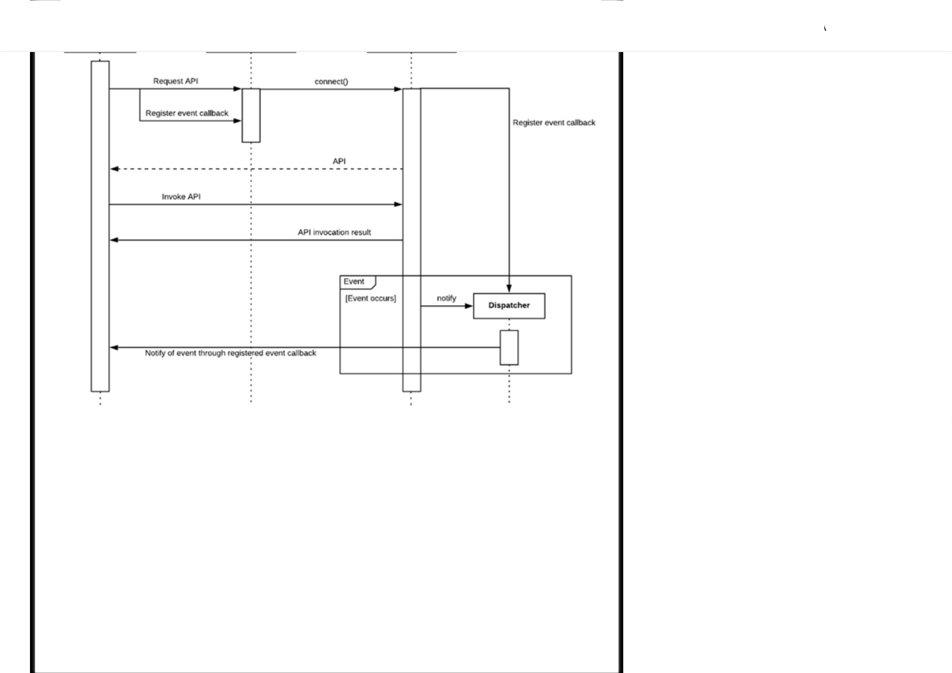

Trimble Connect Workspace API
ll
nherited
Web-based cl ent applications can be embedded inside Trimble Connect for Browser as
extensions.
Extensions can be installed to a project by project administrators either in project or 3D
Viewer settings. They can also be enabled/disabled there.
Custom extensions are installed by providing a manifest url. The manifest structure is
explained later.
Connecting to the API
As extensions are running inside Trimble Connect, the
as follows
method should be invoked
connect
const API = await WorkspaceAPI.connect(window.parent, ...);
Authentication
In the case of extensions, the Connect application will manage the user session and
accessToken.
When the client application is embedded inside Connect as an extension, the
accessToken
should be retrieved by calling the
API. This call will initially
extension.requestPermission
return
while displaying a message requesting for user consent for the extension
pending
to use the _{accessToken}.
If the user gives consent, Connect will emit an
event with the
extension.accessToken
_{accessToken}. This will also happen every time the token is refreshed. Once consent is
given, subsequent API calls will also directly return the _{accessToken}.
If the user has denied the consent, the API call will keep returning _{denied}. The user can
reset the consent status anytime from extension settings.
Manifests and CORS


Trimble Connect Workspace API
ll
nherited
is important that the manifest file url (example:
https://foo.example.manifestfile.com/manifest.json⁾ is CORS enabled to allow access
from Trimble Connect for Browser. For example, when the application tries to fetch the file,
the server should respond with proper CORS response headers (Example: Access-Control-
Allow-Origin, Access-Control-Allow-Methods etc.,). Please refer to Cross-Origin Resource
Sharing (CORS) for details.
1
.1 Trimble Connect 3D Extensions
Trimble Connect for Browser allows integrators to expose additional functionalities in
Trimble Connect 3D Viewer in the context of a project.
Check out the Sample application as an extension.
Example
<
script src="https://components.connect.trimble.com/trimble-connect-workspace-
api/index.js"></script>
<
script>
var API = await TrimbleConnectWorkspace.connect(window.parent, (event, data) =>
{
console.log("Event: ", event, data);
}
);
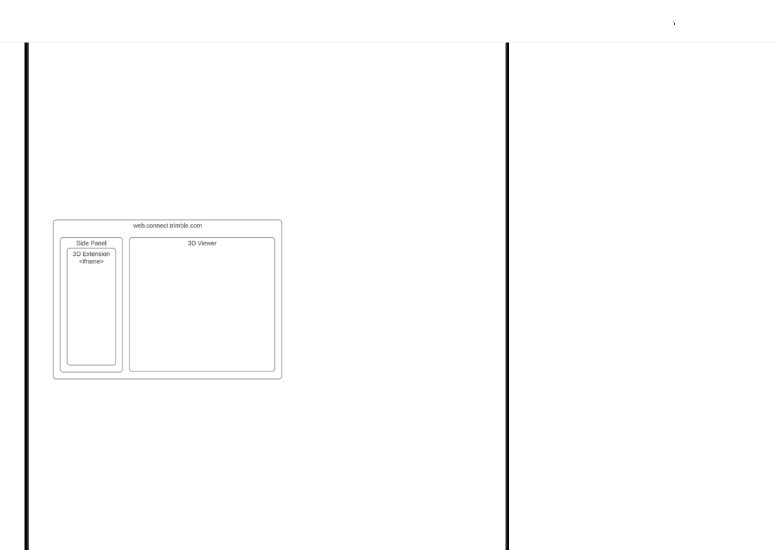

Trimble Connect Workspace API
ll
nherited
}
);
<
/script>
3
D Extension Manifest
The extension manifest is a JSON document that describes the extension parameters. The
data structure follows the
interface, for example:
ExtensionSetting
{
"
"
"
"
url": "https://my.awesome.app/extension",
title": "Awesome extension",
icon": "https://my.awesome.app/extension/favicon.ico",
infoUrl": "https://my.awesome.app/extension/help.html"
}
1
.2 Trimble Connect Project Extensions
Trimble Connect for Browser allows integrators to expose additional functionalities in
Trimble Connect for Browser's file explorer in the context of a project.
This allows creation of new extensions through manifest files and displays the menu
provided by the extension in Connect's left navigation panel. It also allows additional
configuration for the extensions if needed (through configCommand property).
The extension is embedded inside Trimble Connect for Browser application and it will
occupy the middle & right panel within the Project page and the extension menu will
appear in the left panel along with other navigation.

Trimble Connect Workspace API
ll
nherited
Check out the Sample manifest - you can try it out by installing it.
Example
import * as WorkspaceAPI from "trimble-connect-workspace-api";
.
.
...
...
this.API = await WorkspaceAPI.connect(
window.parent,
(event, args) => {
switch (event) {
case "extension.command":
/
/"Command executed by the user: args.data"
break;
case "extension.accessToken":
/
/"Accestoken or status: args.data"
break;
case "extension.userSettingsChanged":
/
/"User settings changed!"
break;
default:
}
}
,
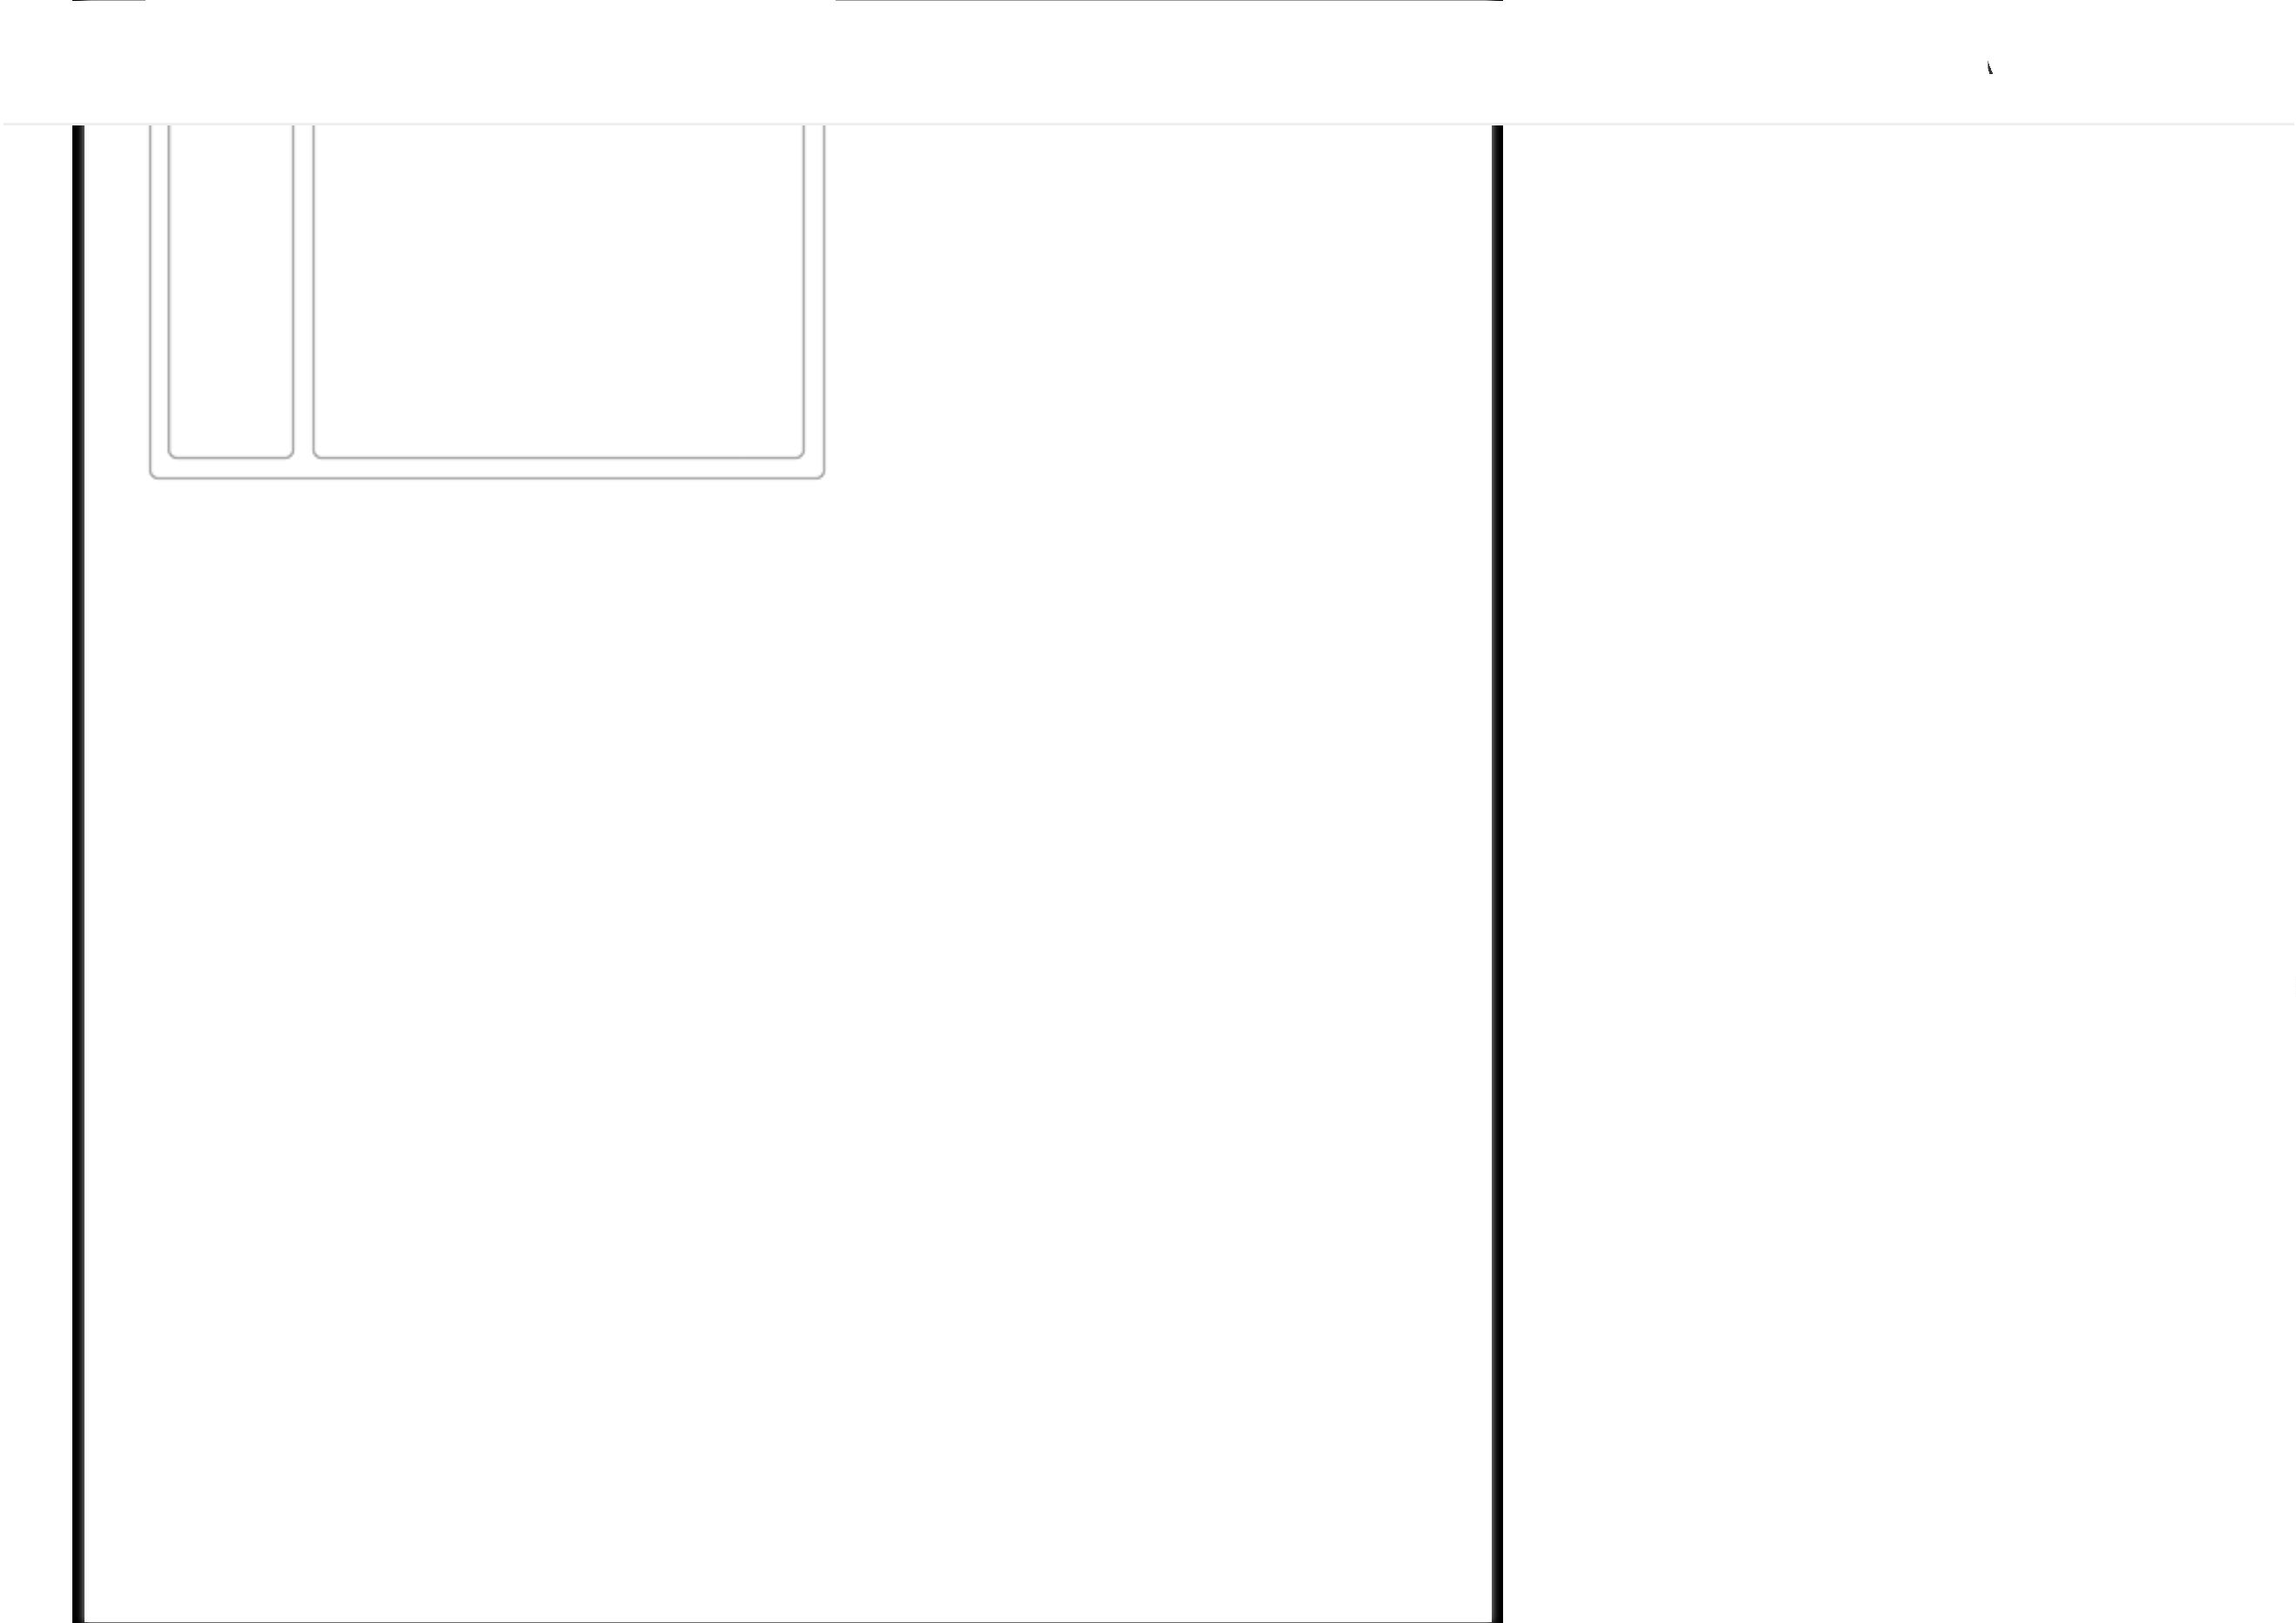

Trimble Connect Workspace API
ll
nherited
.
.
...
...
const mainMenuObject = {
title: "Test extension app",
icon: "http://example.com/main_menu_icon.png",
command: "main_nav_menu_cliked",
subMenus: [
{
title: "Sub menu 1",
icon: "http://example.com/sub_menu_icon.png",
command: "submenu_1_clicked",
}
{
,
title: "Sub menu 2",
icon: "http://example.com/sub_menu_icon.png",
command: "submenu_2_clicked",
}
,
]
,
}
;
/
/ Updating the menu object.
this.API.ui.setMenu(mainMenuObject);
/
/ Updating the active submenu.
this.API.ui.setActiveMenuItem("submenu_1_clicked");
/
/ Get the current project info
this.API.project.getCurrentProject().then((projectInfo: ConnectProject) => {
/Current project info: projectInfo.
/
}
);
/Get the current user language info.
/
this.API.user.getUserSettings().then((userSettings: UserSettings) => {
/
/Current user language: userSettings.language

Trimble Connect Workspace API
ll
nherited
/
/Request for the access token.
this.API.extension.requestPermission("accesstoken").then((accessToken: string) =>
{
/
/Current user access token or status: accessToken
}
);
Example manifest
{
"
"
"
"
"
"
icon": "http://example.com/app_icon.png",
title": "React example",
url": "http://example.com/index.html",
description": "Test extension",
configCommand": "do_config",
enabled": false
}
Project Extension Manifest
Extension is created based on the manifest file shared by the extension author. This can be
done through in Connect through Project Settings -> Extensions page by providing the url
of the manifest file.
The manifest is a JSON document with the following fields
title - Title of the extension to be displayed within Project Settings -> Extensions page.
This field is mandatory.
icon - Icon URL of the extension to be displayed within Project Settings -> Extensions
page. As per current UX, this field is not used but might be used at a later point in time.
This field is optional.
url - URL for extension (that is the integrator application) application. This is expected to
contain the web application that knows how to interact with Connect through Workspace
API - provides the menu to be displayed for the extension, provides configuration UI
(optional) and other interactions. This field is mandatory.


Trimble Connect Workspace API
ll
nherited
when the gear icon(configuration icon) is clicked in the Project Settings -> Extensions
page. This field is optional.
enabled (boolean) - This will set the extension as visible on creation. This field is
optional. Default is false.
2
. Embedded Components
The client application embeds the Trimble Connect components in an iframe.
Connecting to the API
As the Connect component is embedded inside the client application, the
method should be invoked as follows
connect
const component = document.getElementById("<embedded-component-id>");
const API = await WorkspaceAPI.connect(component, ...);
Authentication
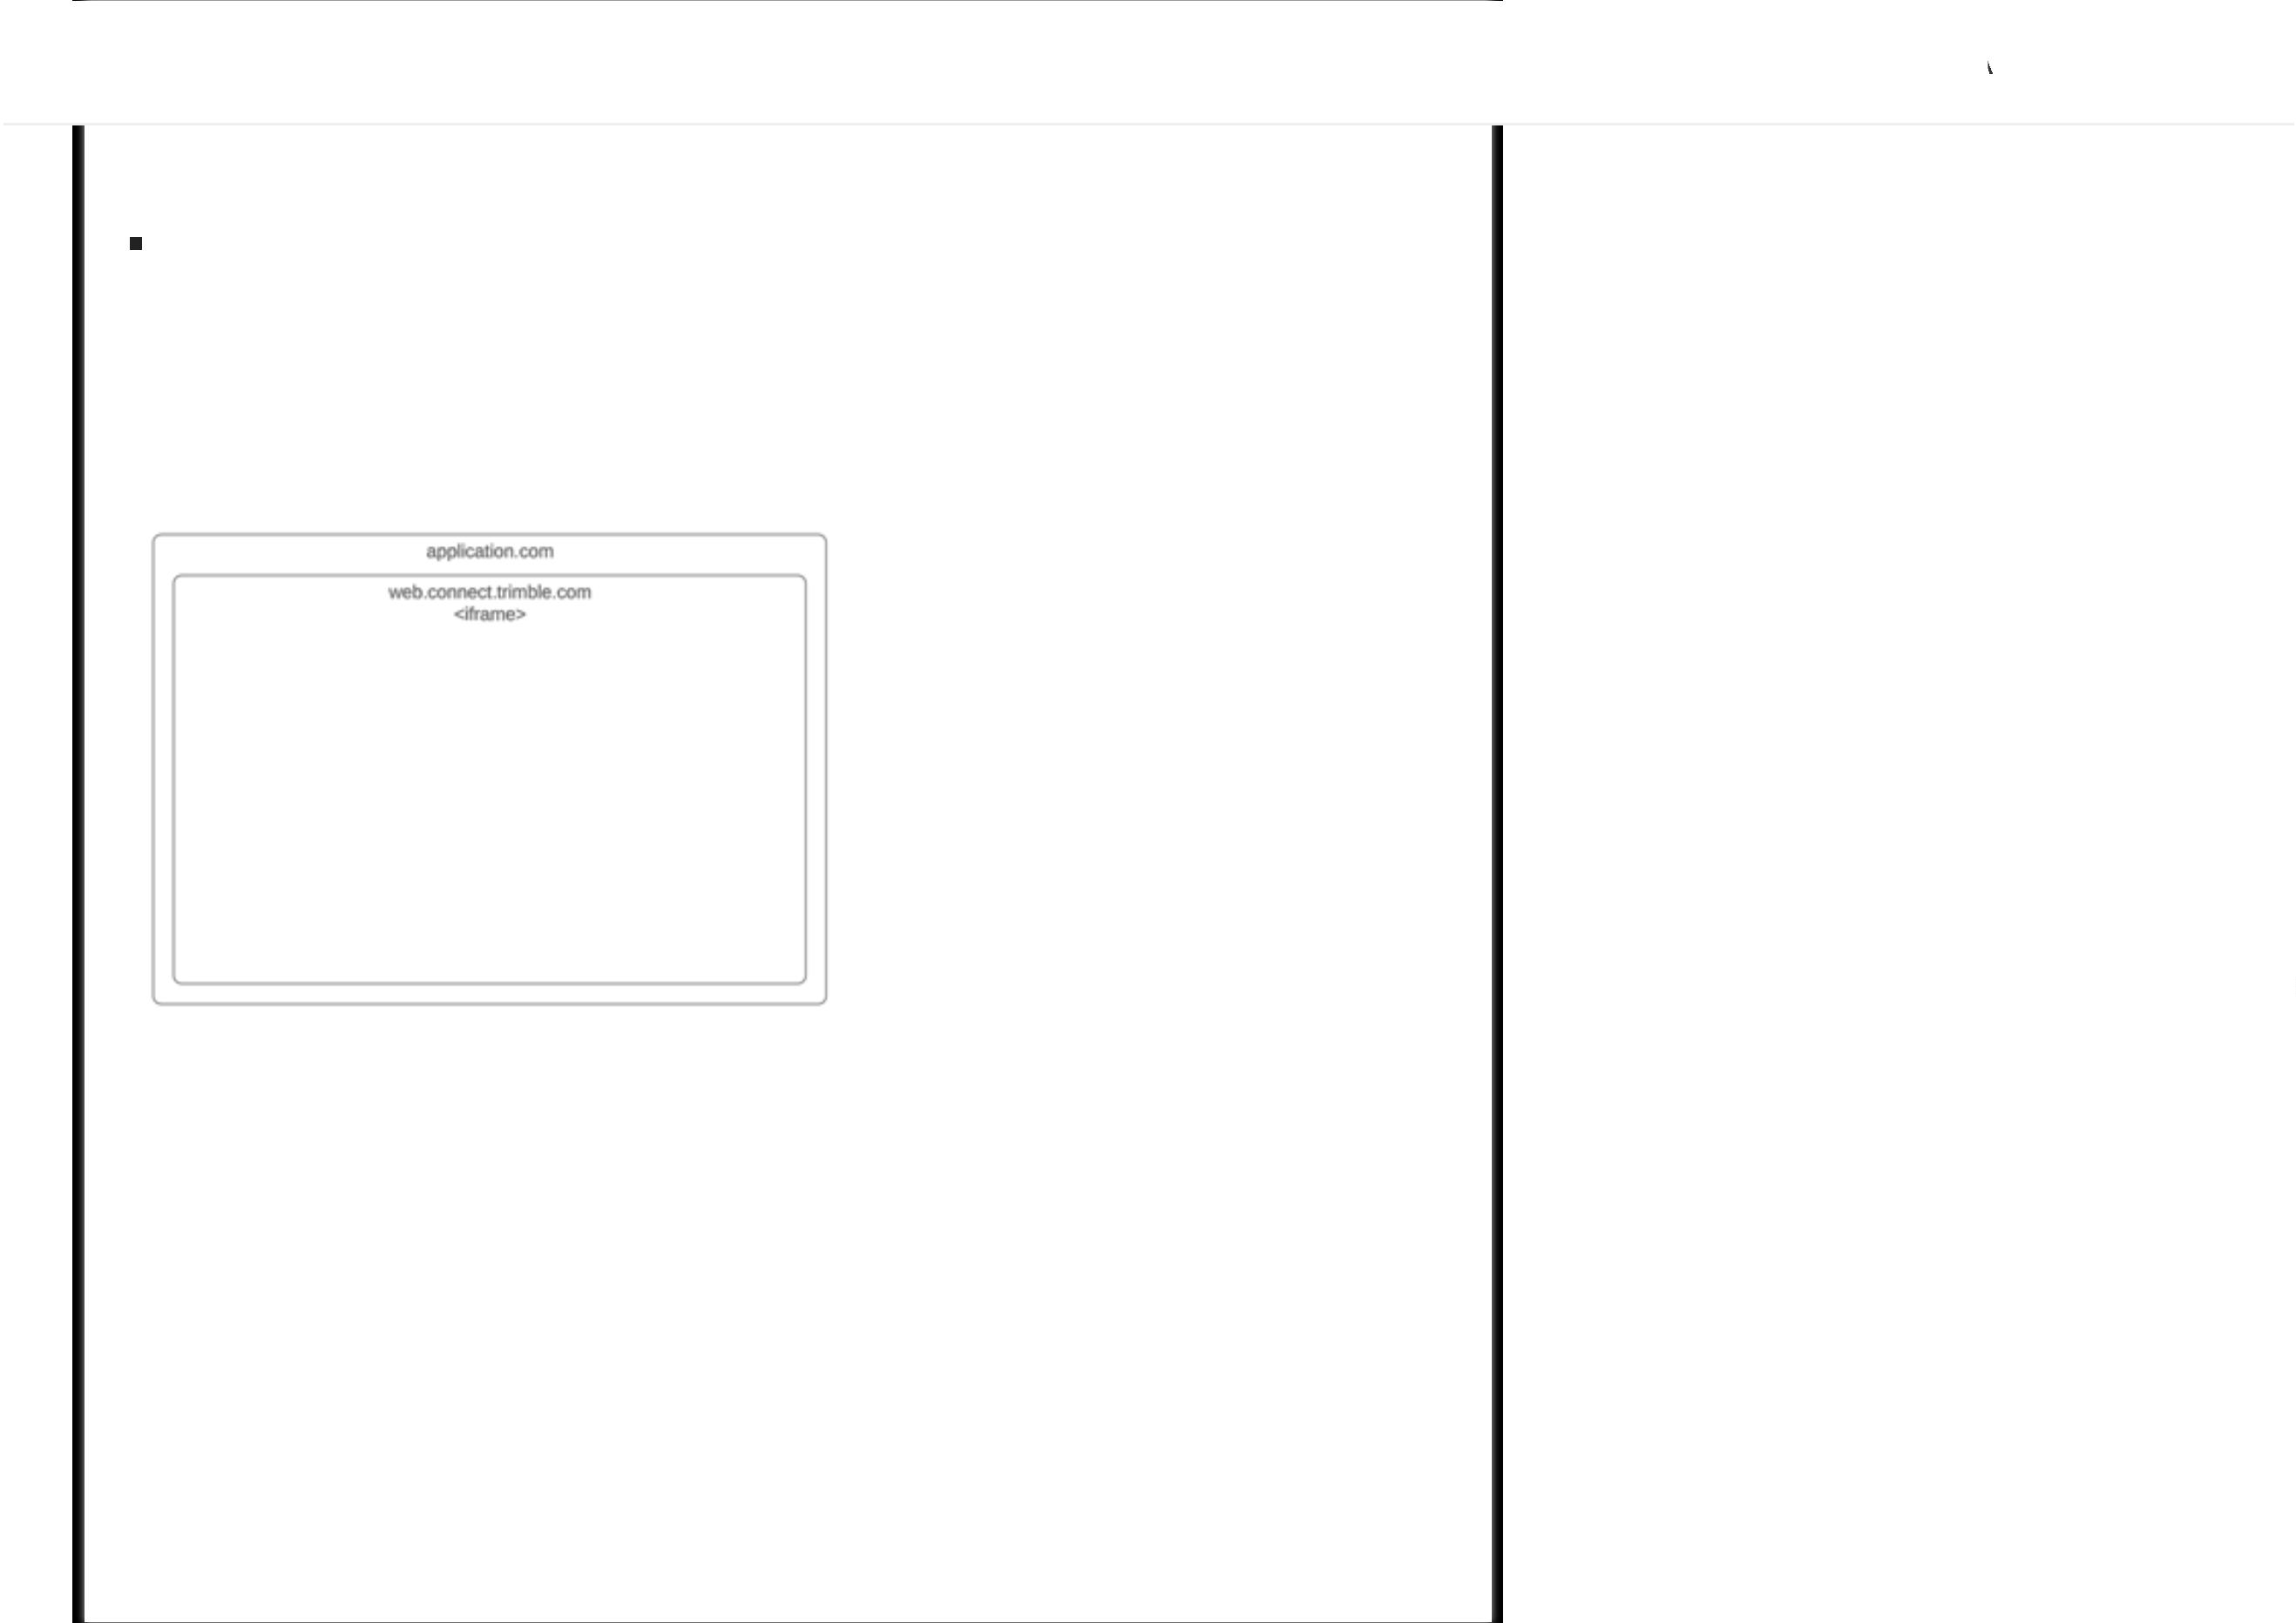

Trimble Connect Workspace API
ll
nherited
It is the client application's responsibility to proactively refresh the
needed. The component will help in the process by emitting the
when
accessToken
event when the
expired or was invalidated. After
accessToken
extension.sessionInvalid
the
is refreshed by the client application, it should be passed back to the
accessToken
component by calling the same
API with the new _{accessToken}.
embed.setTokens
Embedded component authentication is done as follows
await API.embed.setTokens({accessToken: "<accessToken>"});
2
.1 Embedded Trimble Connect 3D Viewer
Embed the 3D Viewer from https://web.connect.trimble.com/?isEmbedded=true inside an
application using an _{iframe}.
The
function is responsible for initializing the Trimble Connect 3D
embed.init3DViewer
Viewer in the embedded context.
Check out the Sample application.
Example
Embed the 3D Viewer inside the application using an _{iframe}: This should be done after
the
has been loaded. The connection initiation should be done in an async
iframe
function as the connection is only established once the user has selected a Trimble
Connect project in the 3D Viewer.
<
script src="https://components.connect.trimble.com/trimble-connect-workspace-
api/index.js"></script>
div>
<
<
<
button onclick="doConnect()">connect</button>
iframe hidden id="viewer" src="https://web.connect.trimble.com/?
isEmbedded=true" width="100%" height="750px"/>

Trimble Connect Workspace API
ll
nherited
viewer.hidden = false;
var API = await TrimbleConnectWorkspace.connect(viewer, (event, data) =>
{
console.log("Event: ", event, data);
);
}
API.embed.setTokens({accessToken: "accessToken_here"});
API.embed.init3DViewer({projectId: "projectId_here"});
}
<
/script>
<
/div>
Query parameters
We recommend using
for setting these parameters. With this method
embed.init3DViewer
you can pass all the possible query params as a
of explicit query params is not needed.
argument to _{init3DViewer}, so use
config
The query parameters can be used to initialize the viewer without any API interaction. In
this case, the 3D Viewer should be embedded using the URL
https://web.connect.trimble.com/projects/:projectId/viewer/3d
where
can be undefined if you want to select a project from the projects list.
projectId
The supported query parameters are:
:
embed https://web.connect.trimble.com/projects/:projectId/viewer/3d/?
Specifies if the application is embedded in a sandboxed environment. If
embed=false
_{true}, the application will emulate the local storage.
:
projectId https://web.connect.trimble.com/projects/:projectId/viewer/3d/?
The id of a project that will be automatically loaded by 3D Viewer,
projectId=projectId
if it exists.
:
modelId https://web.connect.trimble.com/projects/:projectId/viewer/3d/?
The id of a model that will
projectId=projectId&modelId=my_model_id1,my_model_id2


Trimble Connect Workspace API
ll
nherited
:
versionId https://web.connect.trimble.com/projects/:projectId/viewer/3d/?
projectId=project_id&modelId=model_id1,model_id2&versionId=model_version_id1,model_version_id2
The version id of a model that will be automatically loaded by 3D Viewer, if it exists in
the specified project. Used in conjuction with
and _{projectId}. Accepts an array
modelId
of values, separated by comma.
:
viewId https://web.connect.trimble.com/projects/:projectId/viewer/3d/?
The id of a view that will be automatically
projectId=projectId&viewId=my_view_id
loaded by 3D Viewer, if it exists. Used in conjuction with _{projectId}.
:
todoId https://web.connect.trimble.com/projects/:projectId/viewer/3d/?
The id of a to do that will be automatically
projectId=projectId&todoId=my_todo_id
loaded by 3D Viewer, if it exists. Used in conjuction with _{projectId}.
:
clashSetId https://web.connect.trimble.com/projects/:projectId/viewer/3d/?
The id of a clash set that will be
projectId=projectId&clashSetId=my_clash_set_id
automatically loaded by 3D Viewer, if it exists. Used in conjuction with _{projectId}.
:
stoken https://web.connect.trimble.com/projects/:projectId/viewer/3d/?
The 3D Viewer will be authorized using the Trimble Connect
stoken=my_shared_token
share token and will display the shared model(s).
2
.2 Embedded Trimble Connect File Explorer
Initiate Trimble Connect Embedded File Explorer.
The function is responsible for initializing the trimble connect
embed.initFileExplorer
explorer page in the embedded context.
Check out the Sample application.
Example - HTML


Trimble Connect Workspace API
ll
nherited
<
iframe hidden id="explorerIframe" src="#" width="100%" height="750px">
/iframe>
div>
script src="https://components.connect.trimble.com/trimble-connect-
workspace-api/index.js"></script>
<script>
var folderId = `<folderId>`, /*(optional)*/
<
<
<
projectId = `<projectId>`;
var tokenConfig = {
accessToken: `<accessToken>`
}
var explorerConfig = {
projectId,
folderId
}
;
function doConnect(){
var iframeElement = document.getElementById("explorerIframe");
iframeElement.src = TrimbleConnectWorkspace.getConnectEmbedUrl();
iframeElement.hidden = false;
TrimbleConnectWorkspace.connect(
iframeElement,
(event, args) => {
console.log("Event log: ", event, args);
}
,
3
0000,
)
}
.then(async (API) => {
await API.embed.setTokens({ ...tokenConfig });
await API.embed.initFileExplorer({ ...explorerConfig });
);
}
<
/div>
/div>
/script>
<
<
Example - ReactJS

Trimble Connect Workspace API
ll
nherited
export const Projects = () => {
const iframeRef = useRef<HTMLIFrameElement>(null);
const folderId = `<folderId>`, projectId = `<projectId>`, env = "stage";
/
/folderId is optional
const tokenConfig = {
accessToken: `<accessToken>`
}
const explorerConfig = {
projectId,
folderId
}
;
useEffect(() => {
iframeRef.current.src = WorkspaceAPI.getConnectEmbedUrl();
iframeRef.current.hidden = false;
WorkspaceAPI.connect(
iframeRef.current,
(event, args) => {
console.log("Event log: ", event, args);
}
,
3
0000
)
}
.then(async (API) => {
await API.embed.setTokens({ ...tokenConfig });
await API.embed.initFileExplorer({ ...explorerConfig });
);
}
, []);
return (
div>
iframe
<
<
hidden
src="#"
ref={iframeRef}
width="100%"
height="750px"
title="embedExplorer"

Trimble Connect Workspace API
ll
nherited
}
;
2
.3 Embedded Trimble Connect Project List
Initiate Trimble Connect Embedded Project List.
The function is responsible for initializing the trimble connect
embed.initProjectList
projects list page in the embedded context.
Check out the Sample application.
Example - HTML
<
div>
<
<
button onclick="doConnect()">connect</button>
iframe hidden id="projectsIframe" src="#" width="100%" height="750px">
<
/iframe>
div>
script src="https://components.connect.trimble.com/trimble-connect-
workspace-api/index.js"></script>
<
<
<
script>
var tokenConfig = {
accessToken: `<accessToken>`
}
;
var projectEmbedFeatures = {
enableRegion: "na",
enableNewProject: true,
enableCloneProject: true,
enableLeaveProject: true,
enableThumbnail: true,
embedViewMode: "list",
}
;
function doConnect(){
var myIframe = document.getElementById("projectsIframe");

Trimble Connect Workspace API
ll
nherited
myIframe,
(event, args) => {
console.log("Event log: ", event, args);
}
,
3
0000,
)
}
.then(async (API) => {
await API.embed.setTokens({ ...tokenConfig });
await API.embed.initProjectList({ projectEmbedFeatures });
);
}
<
/script>
/div>
/div>
<
<
Example - ReactJS
import React, { useRef, useEffect } from "react";
import * as WorkspaceAPI from "trimble-connect-workspace-api";
export const Projects = () => {
const iframeRef = useRef<HTMLIFrameElement>(null);
const tokenConfig = {
accessToken: `<accessToken>`
}
;
const projectEmbedFeatures = {
enableRegion: "na",
enableNewProject: true,
enableCloneProject: true,
enableLeaveProject: true,
enableThumbnail: true,
embedViewMode: "list",
}
;
useEffect(() => {
if (iframeRef.current) {
iframeRef.current.src = WorkspaceAPI.getConnectEmbedUrl();
iframeRef.current.hidden = false;

Trimble Connect Workspace API
ll
nherited
console.log("Event log: ", event, args);
}
,
3
0000
)
}
.then(async (API) => {
await API.embed.setTokens({ ...tokenConfig });
await API.embed.initProjectList({ projectEmbedFeatures });
);
}
}
, []);
return (
<div>
<iframe
hidden
src="#"
ref={iframeRef}
width="100%"
height="750px"
title="embedProjects"
/
>
<
/div>
)
;
}
;
FAQ
Project Extensions
Who decides on the main navigation menu for the extension? What is the structure of the
menu?
The navigation menu object is passed by the extension application (refers to
the url mentioned in the extension manifest) to Connect and it renders it in

Trimble Connect Workspace API
menu object can contain just two levels - one parent menu item and
ll
nherited
one/more submenu items. Please note that the values in the sample below
are given for illustration purposes only and hence they need to be updated
to reflect your extension’s need.
Dynamic Menu Structure: (received from extension while loading the
extension. extension creator should be aware of this):
{
"
"
"
title": "Quadri shared Model",
icon": "https://abcd.com/images/q.svg",
command": "QUADRI_TOP_MENU", /*This will be passed to the extension when the
menu is licked*/
"
subMenus": [
{
"
"
"
title": "Quadri shared Modelsubmenu1",
icon": "https://abcd.com/images/q1.svg",
command": "QUADRI_SUB_MENU1", /*This will be passed to the extension when
the menu is clicked*/
}
{
,
"
"
"
title": "Quadri shared Model submenu2",
icon": "https://abcd.com/images/q2.svg",
command": "QUADRI_SUB_MENU2", /*This will be passed to the extension when
the menu is clicked*/
}
,
]
}
Are the extension manifest url and the extension url the same?
No, they're not.

Trimble Connect Workspace API
ll
nherited
Extension url is the actual url where the extension application is deployed.
This is set within the manifest file.
Can I pass query params along with submenu command while calling setActiveMenuItem?
Yes, you can.
This may be useful for some extensions if they want use the same submenu
for different states/routes (identified through query parameters) which are
dynamic in nature.
Example scenario - Let's assume the submenu command is _{task}. If the
API is called with the command _{task?id=7}, this will make the
setActiveMenu
'
task' submenu active and the extension will receive what (command with
query parameters - task?id=7) it has passed to the Connect application.
Embedded Components
After an access token has been expired for a few hours, may API.embed.setTokens still be
used to wake up the connection?
The embed.setTokens should be called with a new accessToken before the
current token expires in order to maintain the seamless user experience.
What is the difference between the error messages received during the integrations with
the trimble-connect-workspace-api - “Please refresh the user session. The user session is
invalid” and “Access Denied. You don’t have access to the Trimble Connect for Browser
modules"
The 1st error will appear when the given accessToken is expired. The 2nd
error will appear when the embed.setTokens is called without an
accessToken.
Will the same event "embed.session.invalid" be sent for both cases mentioned above?

Trimble Connect Workspace API
ll
nherited
embed.setTokens will resolve with false. The embed.session.invalid event will
be passed only when the accessToken is expired
Support
Please send your questions to connect-support@trimble.com.
Legend
Property
Method
Settings
Theme OS


